Jefferson Transit Authority
2018 Annual Budget
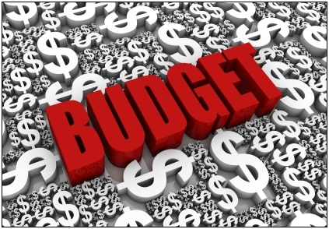

November 14, 2017
Revised November 21, 2017
Approved Via Resolution 17-30
FINAL

Table of Contents

General Manager’s Message 3
Jefferson Transit Authority Mission Statement 4
Overall Economic Outlook 5
Budget Summary – All Departments 6
Capital Expansion 7
Capital Budget 8
Service, Routes, and Ridership 9
Revenue 9
Jefferson Transit Staff 10
Jefferson Transit Organization Chart 11
Operation Department Budget 12
Haines Place Transit Center Department Budget 13
Vehicle Maintenance Department Budget 14
Facility Maintenance Department Budget 15
Administration Department Budget 16
Jefferson Transit Olympic Connection Budget 17
5-Year Projections 18
Cash Flow Projections 19
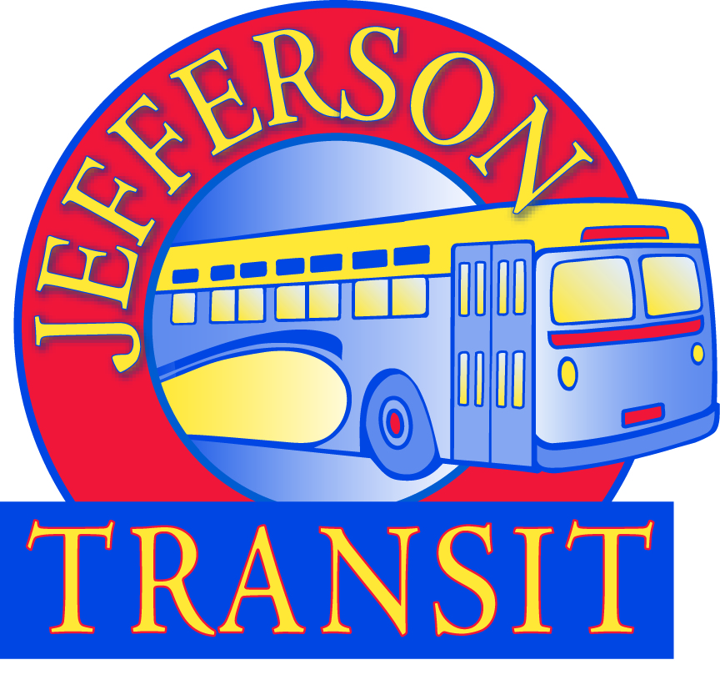
To the Honorable Jefferson Transit Authority Board and Jefferson County Residents
Jefferson Transit would like to take this opportunity to thank you all for the trust placed in us to provide safe and reliable service to our community. I am inspired by the support our Authority Board and our community place in us every day. Jefferson Transit is delivering on its promise to provide more service, to more places beginning in 2018. Our goal is to provide sustainable transportation using data gathered, careful planning and public input.
Jefferson Transit contributes to the economic growth and quality of life for the residents of Jefferson County by offering transportation choices for over 285,000 passengers each year. Jefferson Transit is the hub that connects the entire Olympic Peninsula to jobs, services, healthcare, recreation, shopping, and school.
2018 will be an exciting year for Jefferson Transit. According to the Office of Financial Management (OFM), 2016 Population Trends, Jefferson County shows small but steady increases in population since 2000. The 2018 budget positions the agency to support and serve Jefferson County’s growth by providing sustainable service increases. Jefferson Transit’s plan to increase service relies on the successful planning and budgeting process to achieve this goal. Jefferson Transit will continue its efficiencies and cost containment to enable us to deliver and sustain long-lasting results.
Jefferson Transit’s planning consists of the increased use of technology and updating our Long Range Comprehensive Transit Plan. The process began in October 2017, with the issuance of a Request for Qualifications (RFQ) and is expected to be complete by the end of 2018. The comprehensive plan is expected to provide a vision for a regionally integrated transit network in Jefferson County that will support the economy and protect our quality of life. Our planning efforts will continue to be integrated with local jurisdictions to support transit-oriented development and transit-friendly roads.
In 2017, Jefferson Transit invested in infrastructure to support the increased services planned for 2018 by building a Park and Ride located at the Four Corners Base. The Park and Ride provide an additional 50 parking spaces, bike barn and two electric vehicle charging stations intended to improve the delivery of service and experience to our passengers.
In 2017, Jefferson Transit began to reserve funds for future replacement of its vehicles and in 2018 will begin to reserve funds for replacement of its technology. The future of Jefferson is clear and exciting. Our operational and capital plans are adequately funded. Jefferson Transit’s financial health is protected by its reserves and will ensure sustainability. It is a privilege to serve this agency and this community.
Thank you for the continued support of Jefferson Transit.
Tammi Rubert, General Manager
Jefferson Transit Authority Mission Statement
At Jefferson Transit our mission is to provide safe, reliable, comfortable public transportation service in Jefferson County which is cost effective, reduces energy consumption and contributes to the cultural and economic betterment of the residents of Jefferson County.
Jefferson Transit Core Values:
Acknowledgment and Support
Jefferson Transit is the product of the concerted efforts of the employees, the Board, WSDOT, other transit agencies and the volunteers who devote time to improving Jefferson Transit. We also acknowledge the citizens of Jefferson County, the tax payers, and our passengers for their support of Jefferson Transit. Thank you.
Accountability
We take responsibility for the direction and image of Jefferson Transit. We display fairness, trust and good judgment.
Shared Responsibility
We are responsible for the direction and image of the agency.
Communication
We recognize that good communication, compromise and diversity of opinion will strengthen Jefferson Transit.
Professionalism
We take pride in our skills and abilities to provide the community with safe, friendly and reliable transportation. We strive for a positive impact through our demeanor and appearance.

Jefferson Transit is proud to present the 2018 budget to the public. We are committed to providing safe, reliable and SUSTAINABLE public transit services far into the future.

Overall Economic Outlook
The following statement is made every year, but it needs to be repeated: “The majority of Jefferson Transit’s revenue is generated from sales tax collected in Jefferson County. This form of funding is inherently unstable.” In 2015 and 2016 Jefferson Transit enjoyed double digit percentage increases in sales tax revenue over the previous year. The forecast for 2017 predicts only a 1.5 to 2 percent increase over 2016. Healthcare benefits, fuel prices, and labor expenses continue to increase. Jefferson Transit is at the legislative maximum for sales tax. Jefferson Transit will continue to speak to legislators regarding a stable transportation funding package.
Through fiscally responsible budgeting and spending, Jefferson Transit has been able to set aside funds for Capital and Operating Reserves. The Operating reserve is now fully funded, a full two years ahead of schedule. For 2018 Jefferson Transit is ready to propose service/route changes to the public. In this time of economic and funding uncertainty, we need to ensure that we provide service that will be sustainable if sales tax revenue decreases and grant funding is no longer available.
Capital Reserve funding is and will continue to be an ongoing concern. Jefferson Transit set up its capital reserve fund policy to set aside funds for future grant fund match or when self-funding capital purchases. Jefferson Transit requires grant funding for fixed route replacement vehicles. In order to maintain high quality vehicles that are both fuel-efficient and economically maintained, vehicles must be replaced on an ongoing basis. In 2017 Jefferson Transit established a vehicle replacement reserve fund because grant funding is increasingly difficult to obtain. With the reserve fund we can purchase a full-size fixed route bus once every four years, however, Jefferson Transit needs other revenue and service vehicles as well as fixed route buses. We were fortunate to receive grant funding to replace two of our Dial-a-Ride cutaways and four of our fixed route buses in 2017. The Dial-A-Ride cutaways will be delivered in early 2018. The fixed route buses will be delivered in late 2018 and early 2019.
Jefferson Transit has invested in improved technology in order to increase our knowledge base to find efficiencies and propose service changes. Technology is required for every action transit takes. We use it to track ridership, prepare financial reports, track maintenance and repair of vehicles and a myriad of other tasks. In 2018 we must update our finance/maintenance software in response to increased reporting responsibilities. We will also ask the Board to consider a change to the Reserve Policy to include a Technology Component Replacement Reserve similar to our Vehicle Replacement Reserve in order to fund hardware replacement every 5-7 years.
Jefferson Transit will continue to be conservative in budgeting and will continue to monitor all expenses carefully. The 2018 overall expense budget has increased over the 2017 budget by 10.3%. The increase in the budget is primarily attributed to adding new represented positions to go along with expanding service.
Budget Summary – All Departments

JEFFERSON TRANSIT AUTHORITY
Statement of Operating Revenues, Expenses and Nonoperating Revenues
2018 Operating Budget
Operating - Summary By Department
 |  |  | 2018 Budget Compared to 2017 Budget | 2017 Actual/ Forecast | 2017 Budget | 2018 Budget
OPERATING REVENUES:
 | PASSENGER FARES FOR TRANSIT SERVICES |  | (3.53%) | $ 187,696 | 215,600 | 208,000
 | OTHER TRANSIT FARES |  | 0.00% | 0 | 0 | 0
 | CHARTER SERVICE REVENUES |  | 0.00% | 0 | 0 | 0
 | AUXILIARY TRANSPORTATION REVENUES |  | 0.00% | 0 | 0 | 0
 | Total Operating Revenues |  | (3.53%) | 187,696 | 215,600 | 208,000
OPERATING EXPENSES:
 | LABOR |  | 10.67% | 1,903,920 | 1,982,558 | 2,194,041
 | BENEFITS |  | 7.62% | 1,413,039 | 1,556,799 | 1,675,485
 | SERVICES AND USER FEES |  | 21.36% | 196,870 | 245,035 | 297,370
 | MATERIALS AND SUPPLIES CONSUMED |  | 15.78% | 409,455 | 545,460 | 631,560
 | UTILITIES |  | 4.04% | 74,848 | 80,020 | 83,253
 | CASUALTY AND LIABILITY COSTS |  | 3.94% | 122,634 | 127,000 | 132,000
 | TAXES |  | 0.73% | 3,814 | 7,953 | 8,011
 | DEBT SERVICE |  | 0.00% | 51,072 | 35,755 | 35,755
 | MISCELLANEOUS EXPENSES |  | 6.46% | 51,191 | 87,665 | 93,332
 | LEASES AND RENTALS |  | 0.00% | 16,730 | 18,640 | 18,640
 | Total Operating Expenses |  | 10.30% | 4,243,574 | 4,686,886 | 5,169,448
OPERATING INCOME (LOSS) |  |  | 0.00% | (4,055,877) | (4,471,286) | (4,961,448)
NONOPERATING REVENUES (EXPENSES)
 | NONTRANSPORTATION REVENUES |  | 0.00% | 56,727 | 24,000 | 24,000
 | TAXES LEVIED DIRECTLY BY TRANSIT SYSTEM |  | 5.97% | 4,674,509 | 3,931,572 | 4,166,099
 | LOCAL GRANTS AND CONTRIBUTIONS |  | 0.00% | 19,000 | 17,500 | 17,500
 | STATE GRANTS AND CONTRIBUTIONS |  | 1.36% | 366,950 | 251,579 | 255,000
 | FEDERAL GRANTS AND CONTRIBUTIONS (OPERATING) |  | 19.81% | 691,341 | 801,284 | 960,000
 | Total Nonoperating Revenues (Expenses) |  | 7.89% | 5,808,527 | 5,025,935 | 5,422,599
NET INCOME (LOSS) BEFORE TRANSFERS IN (OUT) |  |  |  | 1,752,649 | 554,649 | 461,151

Capital Expansion
Capital expansion in 2018 is based upon funding availability. Jefferson Transit was awarded Capital Vehicle funding from the surface transportation program to replace two fixed route buses. The 2017-2019 WSDOT Consolidated Grant awarded funds for the replacement of two additional fixed route buses and two dial-a-ride cutaway buses.
Jefferson Transit has included JTA funded projects for Haines Place Park and Ride upgrades, the Jefferson Transit Comprehensive Plan and the Maynard Mountain Repeater project. These projects were included in the 2017 budget but were not completed. There are also ongoing funding included for Engine/Transmission replacement and bus painting.
Jefferson Transit will purchase a replacement service/tool van for facility maintenance as well as two service supervisor vehicles. A parking lot striper is included in the budget for facilities maintenance as well as planning software for operations. Finance/Maintenance Software is scheduled to be purchased as well.
Jefferson Transit will also purchase security cameras for both the Haines Place Park and Ride and 63 4 Corners. Jefferson Transit received a small risk management grant in 2017 from our Washington State Transportation Insurance Pool to install cameras at Haines Place. Additionally, there is a server room fire protection project and a new bus stop signage project.
See next page for Capital Budget

Statement of Capital Outlays, Revenues and Contributions
2018 Capital Budget
Capital Expenditures and Nonoperating Revenues
 |  | Allocated Funding Year |  | Total JTA Outlay |  | Total Contributed Capital Grants |  | Total
CAPITAL EXPENSES
Capital Project - Facility
 |  |  |  |  |  | 0 |  | 0
 |  |  |  | 0 |  | 0 |  | 0
Capital Project - System Wide
Capital Assets - Other Building & Structures
 | Haines Place Park and Ride | 2016
 | Bathroom Installation |  |  | 187,000 |  |  |  | 187,000
 | Sidewalk/Concrete Tree Removal |  |  | 8,000 |  |  |  | 8,000
 | Paint Roof of HPTC Building |  |  | 15,000 |  |  |  | 15,000
 | Radio Project - Maynard Mountain Repeater | 2017 |  | 22,000 |  |  |  | 22,000
 | Security Cameras | 2018 |  | 35,000 |  | 2,500 |  | 37,500
 | Server Room Fire Protection Project | 2018 |  | 30,000 |  |  |  | 30,000
 | New Bus Stop Way Finding Signage | 2018 |  | 10,000 |  |  |  | 10,000
 | New Shelters | 2018 |  | 25,000 |  |  |  | 25,000
 |  |  |  | 332,000 |  | 2,500 |  | 334,500
Capital Assets - Revenue Vehicles
 | 2 full size fixed route buses (STP/Flex) | 2016/2017 |  | 210,000 |  | 790,000 |  | 1,000,000
 | 2 full size fixed route buses (Consolidated) | 2017/2019 |  | 219,000 |  | 717,439 |  | 936,439
 | 2 DAR Cut-a-ways | 2018 |  | 32,000 |  | 128,000 |  | 160,000
 | Bus Painting | Ongoing |  | 25,000 |  |  |  | 25,000
 | Vehicle Engine/Transmission Replacement | Ongoing |  | 150,000 |  |  |  | 150,000
 |  |  |  | 636,000 |  | 1,635,439 |  | 2,271,439
Capital Assets - Service Vehicles
 | Shop Maintenance Van (w/Tool Carriers, Lift and Generator hook-up) | 2018 |  | 100,000 |  |  |  | 100,000
 | Service Supervisor Vehicles (2) | 2018 |  | 80,000 |  |  |  | 80,000
 |  |  |  | 180,000 |  | 0 |  | 180,000
Capital Assets - Service Equipment
 | Parking Lot Striper | 2018 |  | 7,500 |  |  |  | 7,500
 |  |  |  | 7,500 |  | 0 |  | 7,500
Capital Assets - Office Furniture & Equipment
 | New Finance/Maintenance Software | 2017 |  | 175,000 |  |  |  | 175,000
 | Remix Mapping Software | 2018 |  | 12,000 |  |  |  | 12,000
 |  |  |  | 187,000 |  | 0 |  | 187,000
Capital Assets - Construction in Progress
 | N/A |  |  | 0 |  | 0 |  | 0
TOTAL CAPITAL EXPENSES |  |  |  | 1,342,500 |  | 1,637,939 |  | 2,980,439

Service, Routes and Ridership
Service levels are expected to expand responsibly. Responsibly means that any changes made to service levels will be sustainable during future economic downturns. Jefferson Transit is exploring affordable options to expand service in core areas as well as react to a long term road construction project in Port Townsend. Jefferson Transit will roll out service changes in January 2018.

Revenue
Sales tax receipts are projected to be 5.97% higher ($234,527 more) than budgeted for 2017. The breakdown for all of Jefferson Transit’s revenue streams appears below.

Jefferson Transit Staff
In 2018 Jefferson Transit plans to add the equivalent of 2 full-time operator positions, a mechanic, and a field supervisor position will be added. The following table lists the FTE (Full Time Equivalent) and EE (Employee Headcount) numbers since 2013 and the projected for 2018. FTEs are calculated by projecting the number of employees and dividing that number by the typical hours available in a work year. There are 2080 hours in a typical working year.
Position | 2018 |  | 2017 |  | 2016 |  | 2015 |  | 2014 |  | 2013
 | FTE | EE | FTE | EE | FTE | EE | FTE | EE | FTE | EE | FTE | EE
Transit Operators – FR | 17.2 | 18 | 13.6 | 16 | 13.8 | 15 | 13.8 | 15 | 13.4 | 16 | 13.4 | 15
Transit Operators – DAR | 2 | 2 | 2 | 2 | 2.7 | 3 | 3.6 | 4 | 3.4 | 4 | 3 | 3
Transit Operators - JTOC | 2.6 | 3 | 2.8 | 3 | 2.6 | 3 | 2.5 | 3 | 2.7 | 3 | 2.8 | 3
Vehicle Maintenance | 5 | 5 | 4 | 4 | 4 | 4 | 4 | 4 | 4 | 4 | 4 | 4
Facility Maintenance | 3.6 | 4 | 3.6 | 4 | 3.9 | 4 | 3.1 | 4 | 2.7 | 4 | 2.8 | 4
Dispatchers/Field Supervisor | 3.9 | 4 | 2.8 | 3 | 4 | 4 | 4 | 4 | 4 | 4 | 5 | 5
Customer Service | 2.6 | 3 | 2.3 | 3 | 2.6 | 3 | 2.5 | 3 | 1.3 | 2 | 1.3 | 2
Admin Support Staff (Incl JTOC Spvr) | 5.5 | 7 | 6.5 | 7 | 5.5 | 7 | 5 | 6 | 5.5 | 6 | 5 | 6
Management | 5 | 5 | 5 | 5 | 5 | 5 | 5 | 5 | 4 | 4 | 4 | 4
Total | 47.4 | 51 | 42.6 | 47 | 44.1 | 48 | 43.6 | 48 | 41.0 | 47 | 41.3 | 46

Jefferson Transit Authority Organizational Chart 2018
Jefferson Transit Authority Board (6)
(2 City Council, 3 County Commissioners, and 1 Non-Voting JTA Union Member)

*Non-Represented Staff
*General Manager (1)
Code: 16-Dept: Admin

*IT Specialist (1)
Code: 16-Dept: Admin
*Executive Assistant/Clerk of the Board (1)
Code: 16-Dept: Admin

*Finance Manager (1)
Code: 16-Dept: Admin
*Operations Manager (1)
Code: 10-Dept: Operations

*Fleet and Facilities Manager (1)
Code: 41-Dept: Fleet/Facilities

*Mobility/Outreach Coordinator (1)
Code: 11-Dept: HPTC
*Service & Training Supervisor (1)
Code: 11
Dept: Operations/HPTC
Facilities Mntce Worker (1)
Code: 42
Dept: Facilities Mntce
Maintenance Clerk (1)
Code: 41
Dept: Vehicle Mntce
*HR & Payroll/Benefits Administrator (1)
Code: 16 Dept: Admin

*AP/AR Specialist (1)
Code: 16 Dept: Admin
Dispatchers (3)
Code: 10
Dept: Operations
Maintenance Cleaner(2)
Code: 42
Dept: Facilities Mntce

Mechanics (3)
Code: 41
Dept: Vehicle Mntce
Field Supervisor (1)
Code: 11
Dept: Operations/HPTC

*Grants & Procurement Coordinator (1)
Code: 16 Dept: Admin
Operators (20)
Code: 10
Dept: Operations
*Custodian
Part-time (1)
Code: 42
Dept: Facilities Mntce
*Customer Service Lead/ Office Assistant (2)
Code: 11 Dept: HPTC
Mntce Serv Worker (1)
Code: 41
Dept: Vehicle Mntce

*JTOC Supervisor (1)
Code: 50
Dept: Operations
*Customer Serv Clerk (1)
Code: 11
Dept: HPTC

Forks Operators (3)
Code: 50
Dept: Operations

OPERATIONS Department
The Operations Department is the largest department at Jefferson Transit. The Operations Department consists of the Transit Operators, Dispatchers, and the Operations Manager. The Operations Department is the front-line department tasked with providing the safe, reliable, and friendly transit service for which Jefferson Transit is known.
Overall, the Operations Department budget has increased 6.89% in 2018. The increase is attributed to the addition of operators on the fixed route service. Operations forecasts a 3.6 FTE increase in operator positions resulting from budgeting additional service hours in 2018. There are increases in Service and User fees for software maintenance fees; in Materials and Supplies Consumed for printing; in Utilities for electrical (not correctly distributed through the department in the past); and in Miscellaneous Expenses for increased training costs for CDL training.

JEFFERSON TRANSIT AUTHORITY
OPERATIONS
 |  |  | 2018 Budget |  | 2017 Budget |  | 2017 Forecast |  | 2016 Actuals
OPERATING EXPENSES:
 | LABOR |  | 1,024,313 |  | 960,520 |  | 926,268 |  | 743,450
 | BENEFITS |  | 861,674 |  | 824,441 |  | 732,011 |  | 558,529
 | SERVICES AND USER FEES |  | 34,200 |  | 34,200 |  | 12,847 |  | 15,633
 | MATERIALS AND SUPPLIES CONSUMED |  | 45,000 |  | 33,500 |  | 26,228 |  | 14,464
 | UTILITIES |  | 21,200 |  | 13,000 |  | 17,892 |  | 7,820
 | CASUALTY AND LIABILITY COSTS |  | 0 |  | 0 |  | 0 |  | 0
 | TAXES |  | 0 |  | 0 |  | 0 |  | 0
 | MISCELLANEOUS EXPENSES |  | 27,915 |  | 27,915 |  | 13,039 |  | 12,838
 | DEBT SERVICE |  | 0 |  | 0 |  |  |  | 0
 | LEASES AND RENTALS |  | 0 |  | 0 |  | 0 |  | 0
 | Total Operating Expenses |  | 2,014,303 |  | 1,893,576 |  | 1,728,285 |  | 1,352,734

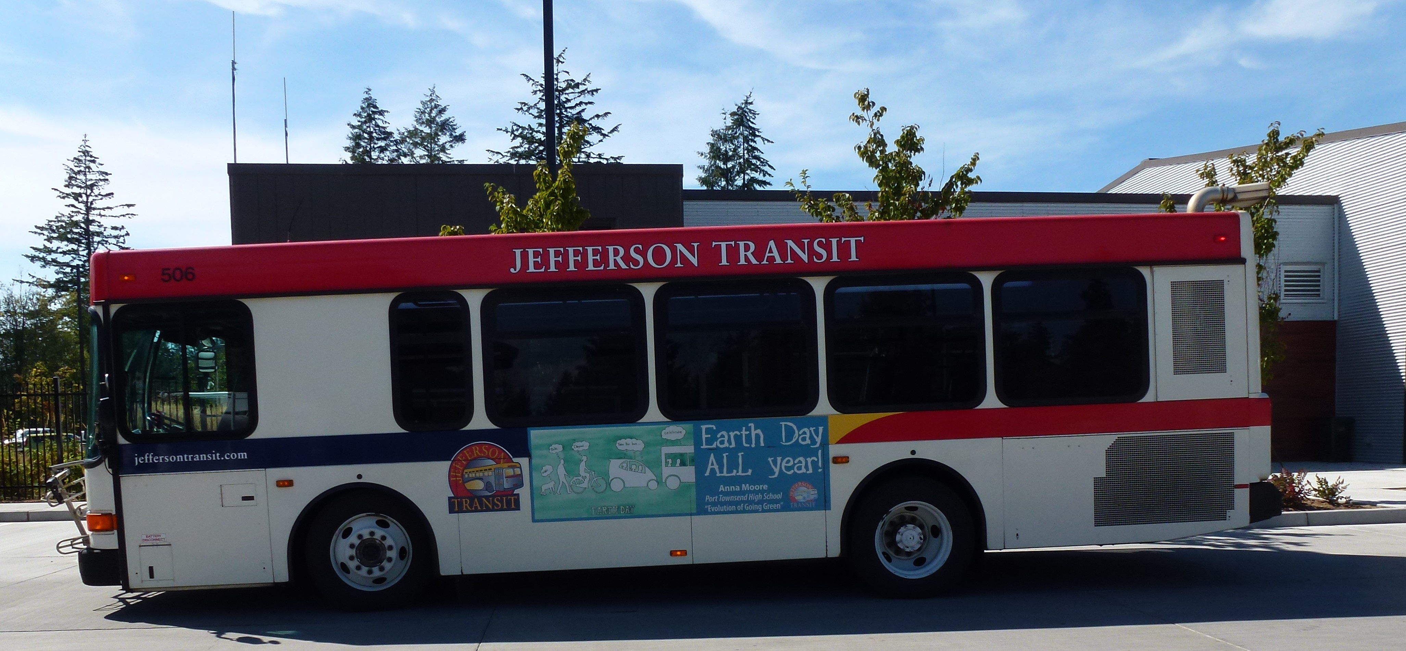
HAINES PLACE TRANSIT CENTER Department
Services provided for passengers are attributed to the Haines Place Transit Center (HPTC) department. The Service and Training Supervisor, Customer Service Clerks, and Field Supervisor salary and benefit expenses are captured in this department.
HPTC’s budget has increased 16.49%. The increase is primarily attributed to the addition of a Mobility Coordinator (hired in August 2017) and Field Supervisor (pending agreement with ATU 587). Other small increases are in Utilities and in Leases and Rentals.

JEFFERSON TRANSIT AUTHORITY
HAINES PLACE TRANSIT CENTER
 |  |  | 2018 Budget |  | 2017 Budget |  | 2017 Forecast |  | 2016 Actuals
OPERATING EXPENSES:
 | LABOR |  | 217,784 |  | 171,608 |  | 131,356 |  | 293,558
 | BENEFITS |  | 145,797 |  | 135,743 |  | 114,931 |  | 209,412
 | SERVICES AND USER FEES |  | 10,105 |  | 10,105 |  | 3,495 |  | 1,360
 | MATERIALS AND SUPPLIES CONSUMED |  | 6,000 |  | 6,000 |  | 2,500 |  | 4,254
 | UTILITIES |  | 21,000 |  | 19,500 |  | 19,500 |  | 22,940
 | CASUALTY AND LIABILITY COSTS |  | 0 |  | 0 |  | 0 |  | 0
 | TAXES |  | 0 |  | 0 |  | 0 |  | 0
 | MISCELLANEOUS EXPENSES |  | 5,930 |  | 6,000 |  | 6,149 |  | 5,125
 | DEBT SERVICE |  | 0 |  | 0 |  | 0 |  | 0
 | LEASES AND RENTALS |  | 3,000 |  | 1,800 |  | 3,290 |  | 2,654
 | Total Operating Expenses |  | 409,617 |  | 350,756 |  | 281,222 |  | 539,303

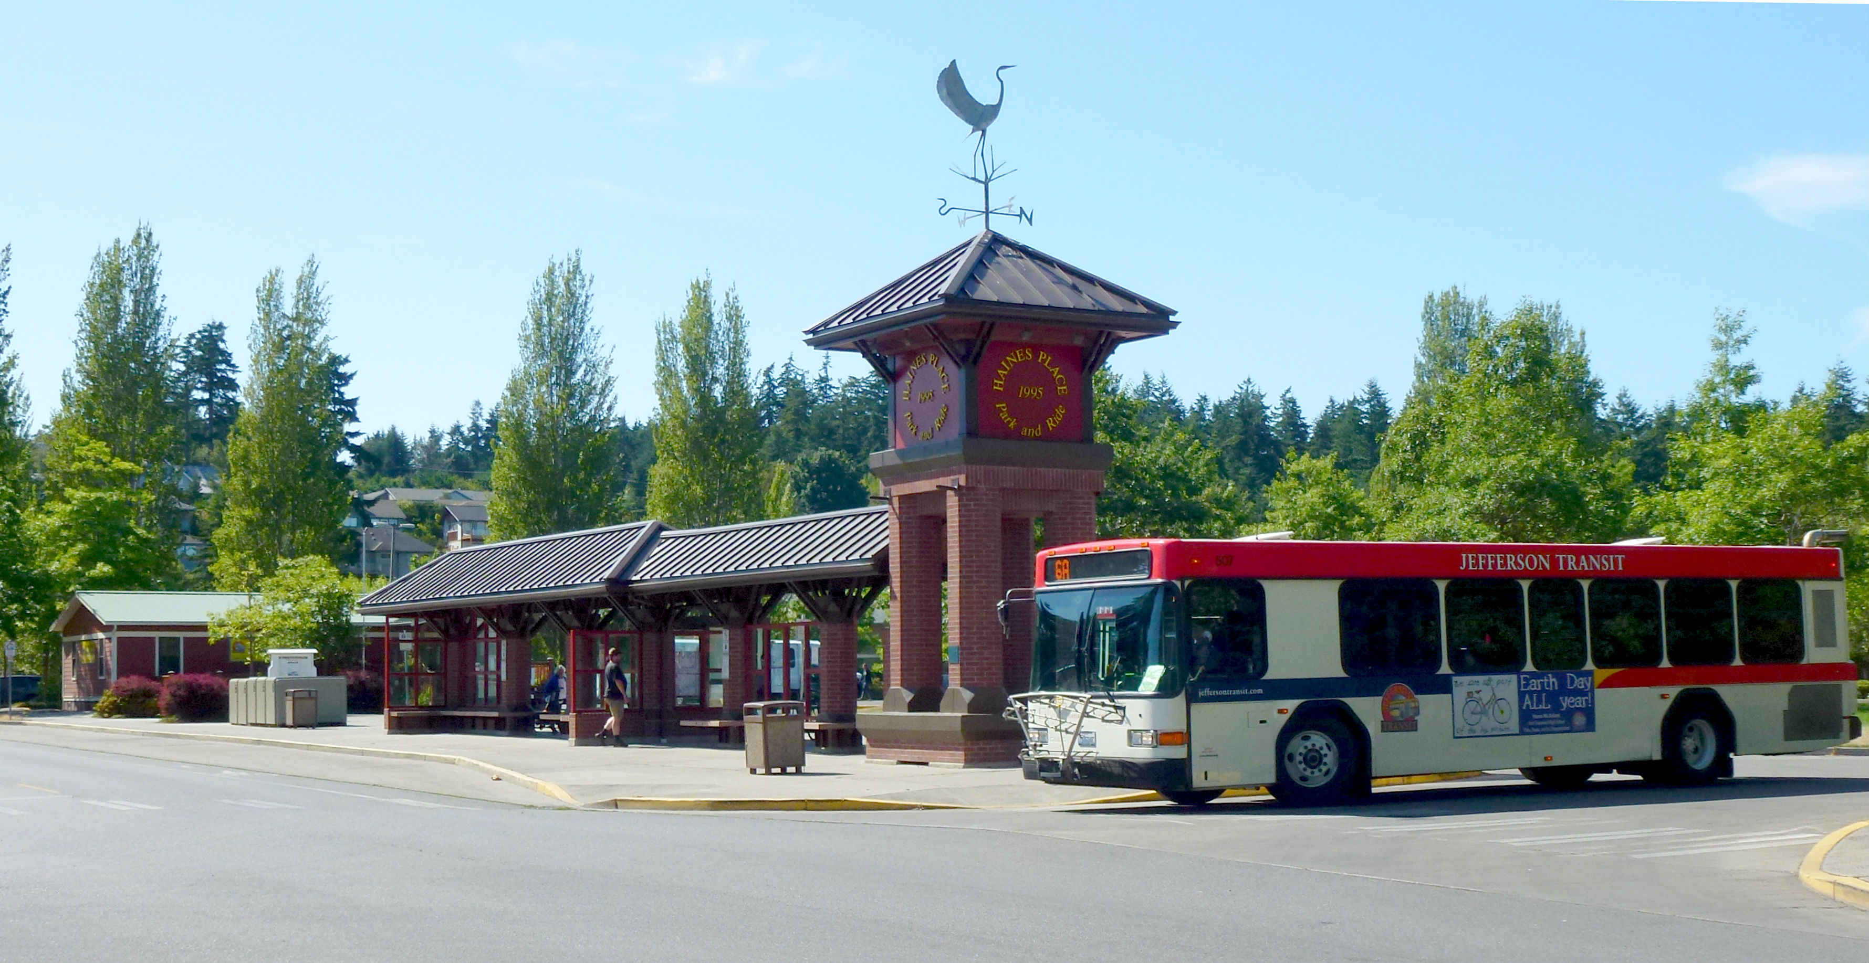
VEHICLE MAINTENANCE Department
The Vehicle Maintenance Department is responsible for the maintenance and safety of all Jefferson Transit vehicles. This department is tasked with the responsibility of parts and fuel procurement and inventory tracking. Included in this department are Mechanics, Maintenance Service, Maintenance Clerk, and Maintenance and Facilities Manager.
Overall, the budget for the Vehicle Maintenance Department has increased 19.69% in 2018. The increase is primarily attributed to the addition of a mechanic. Jefferson Transit has been meeting with Jefferson PUD to discuss providing maintenance services for their fleet. Service and User Fees have increased due to increases in professional services and vehicle technical services. Materials and Supplies have increased due to increased fuel cost projections and vehicle maintenance and repair part increases.
JEFFERSON TRANSIT AUTHORITY
VEHICLE MAINTENANCE
 |  |  | 2018 Budget |  | 2017 Budget |  | 2017 Forecast |  | 2016 Actuals
OPERATING EXPENSES:
 | LABOR |  | 298,167 |  | 232,642 |  | 236,899 |  | 226,427
 | BENEFITS |  | 241,981 |  | 191,333 |  | 186,229 |  | 175,719
 | SERVICES AND USER FEES |  | 31,200 |  | 26,950 |  | 12,628 |  | 8,562
 | MATERIALS AND SUPPLIES CONSUMED |  | 438,000 |  | 385,900 |  | 302,620 |  | 302,549
 | UTILITIES |  | 11,983 |  | 15,050 |  | 10,141 |  | 13,360
 | CASUALTY AND LIABILITY COSTS |  | 0 |  | 0 |  | 0 |  | 0
 | TAXES |  | 0 |  | 0 |  | 0 |  | 0
 | MISCELLANEOUS EXPENSES |  | 15,456 |  | 14,335 |  | 7,082 |  | 5,900
 | DEBT SERVICE |  | 0 |  | 0 |  | 0 |  | 0
 | LEASES AND RENTALS |  | 0 |  | 0 |  | 0 |  | 0
 | Total Operating Expenses |  | 1,036,787 |  | 866,210 |  | 755,598 |  | 732,517

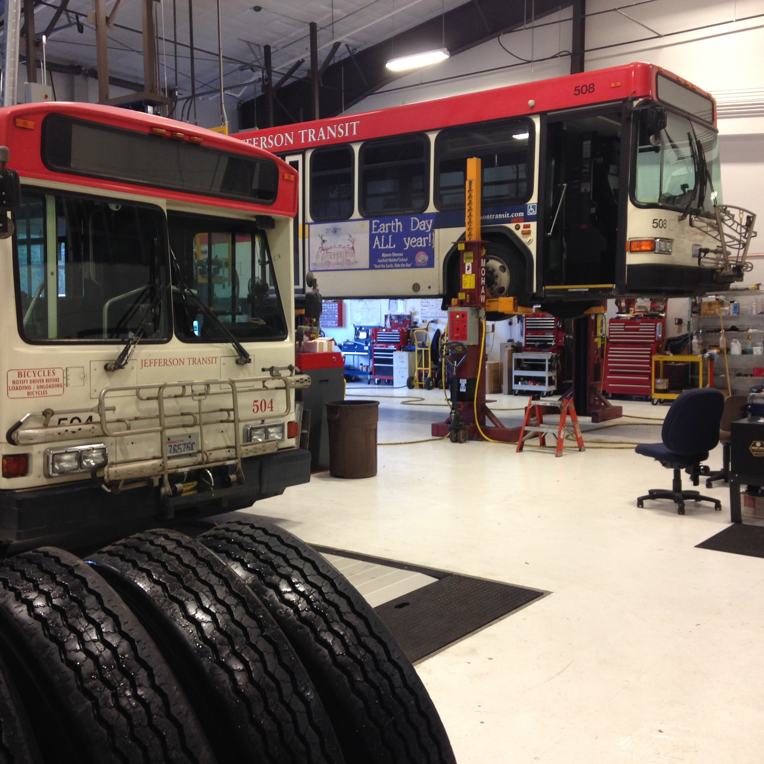
FACILITY MAINTENANCE Department

The Facility Maintenance Department is responsible for the day-to-day maintenance and repair of Jefferson Transit facilities including the Administration and Maintenance facility, Haines Place Transit Center and all bus shelters. The Facility Maintenance Worker has the huge task of ensuring that all facilities are in good repair.
Overall, the budget for the Facility Maintenance Department has increased 8.26% in 2018. This increase is primarily attributed Services and User Fees for landscaping increases in property maintenance services.

JEFFERSON TRANSIT AUTHORITY
NON-VEHICLE MAINTENANCE
 |  |  | 2018 Budget |  | 2017 Budget |  | 2017 Forecast |  | 2016 Actuals
OPERATING EXPENSES:
 | LABOR |  | 111,658 |  | 113,121 |  | 104,439 |  | 107,035
 | BENEFITS |  | 82,317 |  | 82,153 |  | 85,587 |  | 75,549
 | SERVICES AND USER FEES |  | 40,400 |  | 20,200 |  | 12,113 |  | 14,783
 | MATERIALS AND SUPPLIES CONSUMED |  | 23,850 |  | 23,850 |  | 17,671 |  | 19,858
 | UTILITIES |  | 3,850 |  | 5,850 |  | 3,135 |  | 4,206
 | CASUALTY AND LIABILITY COSTS |  | 0 |  | 0 |  | 0 |  | 0
 | TAXES |  | 0 |  | 0 |  | 0 |  | 0
 | MISCELLANEOUS EXPENSES |  | 6,750 |  | 2,950 |  | 2,209 |  | 1,595
 | DEBT SERVICE |  | 0 |  | 0 |  | 0 |  | 0
 | LEASES AND RENTALS |  | 2,500 |  | 2,500 |  | 60 |  | 41
 | Total Operating Expenses |  | 271,325 |  | 250,624 |  | 225,214 |  | 223,067

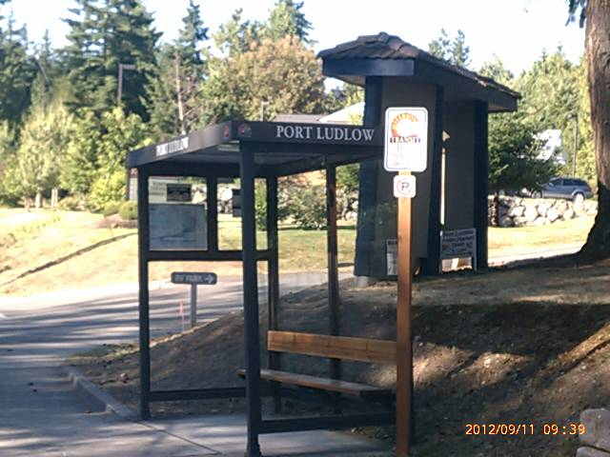
ADMINISTRATION Department
The Administration Department is responsible for the oversight, coordination and management of Jefferson Transit in order to meet its mission of providing safe, reliable, comfortable public transportation service in Jefferson County. The Administration Department includes the General Manager, Finance/HR Manager, IT, Grants/Procurement, Payroll, and AP/AR positions.
Overall, the budget for the Administration Department has increased 8.31% in 2018. The primary increases are in Wages, Benefits, Services and User fees, and Liability Insurance. Professional services has increased due to the single audit expense and additional legal services. Additionally, funding has been included for software maintenance fees that are on a 5 year rotation. The increase in liability insurance is driven by increased costs due to WSTIP’s goal of being able to self-insure the first $7M of a claim by 2021.

JEFFERSON TRANSIT AUTHORITY
General Administration
 |  |  | 2018 Budget |  | 2017 Budget |  | 2017 Forecast |  | 2016 Actuals
OPERATING EXPENSES:
 | LABOR |  | 389,155 |  | 352,481 |  | 357,005 |  | 326,802
 | BENEFITS |  | 238,658 |  | 219,801 |  | 202,913 |  | 191,385
 | SERVICES AND USER FEES |  | 162,115 |  | 143,350 |  | 137,637 |  | 93,772
 | MATERIALS AND SUPPLIES CONSUMED |  | 26,770 |  | 24,270 |  | 18,175 |  | 16,862
 | UTILITIES |  | 20,620 |  | 22,120 |  | 19,392 |  | 20,090
 | CASUALTY AND LIABILITY COSTS |  | 132,000 |  | 127,000 |  | 122,634 |  | 118,565
 | TAXES |  | 7,549 |  | 7,953 |  | 3,814 |  | 5,003
 | MISCELLANEOUS EXPENSES |  | 34,177 |  | 34,177 |  | 22,352 |  | 20,291
 | DEBT SERVICE |  | 35,755 |  | 35,755 |  | 35,390 |  | 36,168
 | LEASES AND RENTALS |  | 0 |  | 0 |  | 0 |  | 0
 | Total Operating Expenses |  | 1,046,798 |  | 966,907 |  | 926,318 |  | 828,938

JEFFERSON TRANSIT OLYMPIC CONNECTION (JTOC)
The Jefferson Transit Olympic Connection is responsible for the operation of the West Jefferson County “lifeline” service from Forks to Amanda Park. There are three Transit Operator positions and one part-time supervisory position in JTOC.
Overall, the budget for JTOC has increased 6.3% over the 2017 budget. The increase is primarily attributed to fuel cost increases.
JEFFERSON TRANSIT AUTHORITY
General Administration
 |  |  | 2018 Budget |  | 2017 Budget |  | 2017 Forecast |  | 2016 Actuals
OPERATING EXPENSES:
 | LABOR |  | 389,155 |  | 352,481 |  | 357,005 |  | 326,802
 | BENEFITS |  | 238,658 |  | 219,801 |  | 202,913 |  | 191,385
 | SERVICES AND USER FEES |  | 162,115 |  | 143,350 |  | 137,637 |  | 93,772
 | MATERIALS AND SUPPLIES CONSUMED |  | 26,770 |  | 24,270 |  | 18,175 |  | 16,862
 | UTILITIES |  | 20,620 |  | 22,120 |  | 19,392 |  | 20,090
 | CASUALTY AND LIABILITY COSTS |  | 132,000 |  | 127,000 |  | 122,634 |  | 118,565
 | TAXES |  | 7,549 |  | 7,953 |  | 3,814 |  | 5,003
 | MISCELLANEOUS EXPENSES |  | 34,177 |  | 34,177 |  | 22,352 |  | 20,291
 | DEBT SERVICE |  | 35,755 |  | 35,755 |  | 35,390 |  | 36,168
 | LEASES AND RENTALS |  | 0 |  | 0 |  | 0 |  | 0
 | Total Operating Expenses |  | 1,046,798 |  | 966,907 |  | 926,318 |  | 828,938

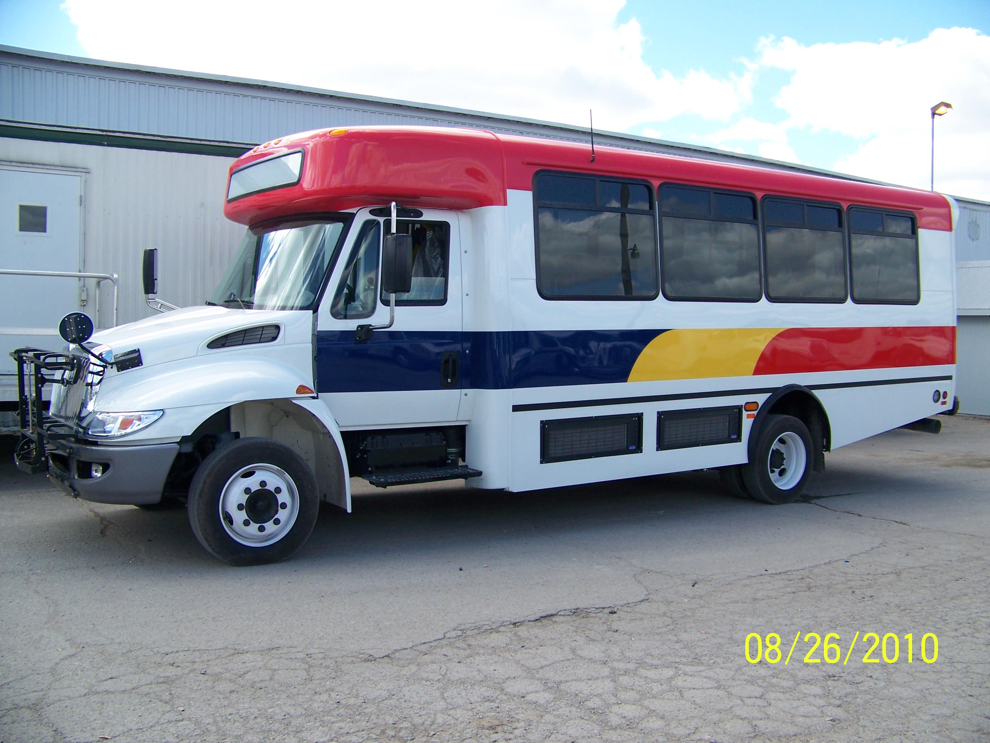

Five Year Projections
JEFFERSON TRANSIT AUTHORITY
Statement of Operating Revenues, Expenses and Nonoperating Revenues
2018 Operating Budget
Operating - Summary By Department
 |  |  | Assumption of 4% Increase in Expenses/3% Increase in Revenues | Assumption of 4% Increase in Expenses/3% Increase in Revenues | Assumption of 4% Increase in Expenses/3% Increase in Revenues | Assumption of 4% Increase in Expenses/3% Increase in Revenues | Assumption of 4% Increase in Expenses/3% Increase in Revenues
 |  | 2018 Budget | 2019 Budget | 2020 Budget | 2021 Budget | 2022 Budget | 2023 Budget
OPERATING REVENUES:
 | Passenger Fares For Transit Services | $208,000 | $212,160 | $216,403 | $220,731 | $225,146 | $229,649
 | Other Transit Fares | $0 | $0 | $0 | $0 | $0 | $0
 | Charter Service Revenues | $0 | $0 | $0 | $0 | $0 | $0
 | Auxiliary Transportation Revenues | $0 | $0 | $0 | $0 | $0 | $0
 | Total Operating Revenues | $208,000 | $212,160 | $216,403 | $220,731 | $225,146 | $229,649
OPERATING EXPENSES:
 | Labor | $2,194,041 | $2,281,803 | $2,373,075 | $2,467,998 | $2,566,718 | $2,669,386
 | Benefits | $1,675,485 | $1,742,504 | $1,812,205 | $1,884,693 | $1,960,080 | $2,038,484
 | Services And User Fees | $297,370 | $309,265 | $321,635 | $334,501 | $347,881 | $361,796
 | Materials And Supplies Consumed | $631,560 | $656,822 | $683,095 | $710,419 | $738,836 | $768,389
 | Utilities | $83,253 | $86,583 | $90,046 | $93,648 | $97,394 | $101,290
 | Casualty And Liability Costs | $132,000 | $137,280 | $142,771 | $148,482 | $154,421 | $160,598
 | Taxes | $8,011 | $8,331 | $8,665 | $9,011 | $9,372 | $9,747
 | Debt Service | $35,755 | $35,755 | $35,755 | $35,755 | $35,755 | $35,755
 | Miscellaneous Expenses | $93,332 | $97,065 | $100,948 | $104,986 | $109,185 | $113,553
 | Leases And Rentals | $18,640 | $19,386 | $20,161 | $20,967 | $21,806 | $22,678
 | Total Operating Expenses | $5,169,447 | $5,374,795 | $5,588,356 | $5,810,460 | $6,041,449 | $6,281,676
OPERATING INCOME (LOSS) |  | ($4,961,447) | ($5,162,635) | ($5,371,953) | ($5,589,729) | ($5,816,303) | ($6,052,027)
NONOPERATING REVENUES (EXPENSES)
 | Nontransportation Revenues | $24,000 | $24,720 | $25,462 | $26,225 | $27,012 | $27,823
 | Taxes Levied By Transit System | $4,166,099 | $4,291,082 | $4,419,814 | $4,552,409 | $4,688,981 | $4,829,651
 | Local Grants And Contributions | $17,500 | $18,025 | $18,566 | $19,123 | $19,696 | $20,287
 | State Grants And Contributions | $255,000 | $262,650 | $270,530 | $278,645 | $287,005 | $295,615
 | Fed Grants And Contrib (Operating) | $960,000 | $988,800 | $1,018,464 | $1,049,018 | $1,080,488 | $1,112,903
 | Total Nonoperating Revenues (Expenses) | $5,422,599 | $5,585,277 | $5,752,835 | $5,925,420 | $6,103,183 | $6,286,278
NET INCOME (LOSS) BEFORE TRANSFERS IN (OUT) |  | $461,152 | $422,642 | $380,882 | $335,691 | $286,880 | $234,251
 | Bond Principal Payment Reserve | $ (45,000) | $ (45,000) | $ (45,000) | $ (45,000) | $ (45,000) | $ (45,000)
 | Transfers In (Out) - Interfund | ($416,152) | ($377,642) | ($335,882) | ($290,691) | ($241,880) | ($189,251)
NET INCOME (LOSS) |  | $0 | $0 | $0 | $0 | $0 | $0
 | 2018 Operational Reserve Balance | $1,300,000 | $1,300,000 | $1,343,699 | $1,397,089 | $1,452,615 | $1,510,362
 | Transfer to Operational Reserve | $0 | $ 43,699 | $ 53,390 | $ 55,526 | $ 57,747 | $ 60,057
 | Operational Reserve Balance | $1,300,000 | $1,343,699 | $1,397,089 | $1,452,615 | $1,510,362 | $1,570,419
 | Capital Reserve Transfer | $416,152 | $333,944 | $282,492 | $235,165 | $184,133 | $129,194

Cash Flow Projections

JEFFERSON TRANSIT AUTHORITY
Statement of Cash Flows
2018 Operating and Capital Budget
 |  |  | 2016 |  | 2017 |  | 2018
 |  |  | Actual |  | Actual (Proj) |  | Budget
CASH FLOWS FROM OPERATING ACTIVITIES
Receipts from Customers |  |  | $ (61,618) |  | $ 187,696 |  | $ 184,000
Payments to Suppliers |  |  | (542,829) |  | (926,615) |  | (1,299,459)
Payments to Employees |  |  | (3,102,650) |  | (3,316,959) |  | (3,869,526)
Change in Accounting method for GASB 68 |  |  | (50,430)
 | Net Cash Provided (Used) by Operating Activities |  | (3,757,527) |  | (4,055,877) |  | (4,984,985)
CASH FLOWS FROM NONCAPITAL FINANCING ACTIVITIES
Sales Tax Receipts |  |  | 4,508,423 |  | 4,674,509 |  | 4,166,099
Other Nonoperating Receipts |  |  | 8,952 |  | 10,218 |  | 10,800
Operating Grant Receipts |  |  | 1,326,891 |  | 1,058,291 |  | 1,215,000
Local Government Assistance Fund Receipts |  |  | 21,250 |  | 19,000 |  | 17,500
 | Net Cash Provided (Used) by Noncapital Financing Activities |  | 5,865,516 |  | 5,762,017 |  | 5,409,399
CASH FLOWS FROM CAPITAL AND RELATED FINANCING ACTIVITIES
Capital Contributions |  |  | 29,146 |  | 2,241,585 |  | 2,861,000
Purchases of Capital Assets |  |  | (542,442) |  | (4,504,109) |  | (2,917,428)
Sale of Capital Assets |  |  | 581,704 |  | 1,371 |  | 0
 | Net Cash Provided (Used) by Capital and Related Financing Activities |  | 68,408 |  | (2,261,153) |  | (56,428)
CASH FLOWS FROM INVESTING ACTIVITIES
Interest and Dividends |  |  | 16,495 |  | 46,509 |  | 12,000
 | Net Cash Provided by Investing Activities |  | 16,495 |  | 46,509 |  | 12,000
 |  | Net Increase (Decrease) in Sales and Cash Equivalents | 2,192,892 |  | (508,504) |  | 379,986
Balances - Beginning of the Year |  |  | 3,756,937 |  | 5,949,829 |  | 5,441,325
 | Prior Period Adjustment |  | 0 |  | 0 |  | 0
Balances - End of the Year |  |  | $ 5,949,829 |  | $ 5,441,325 |  | $ 5,821,311

